IMPETUS CORPORATION

EE 493 Design Studio 1

Business Statement Report

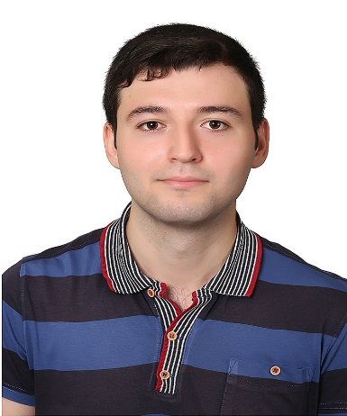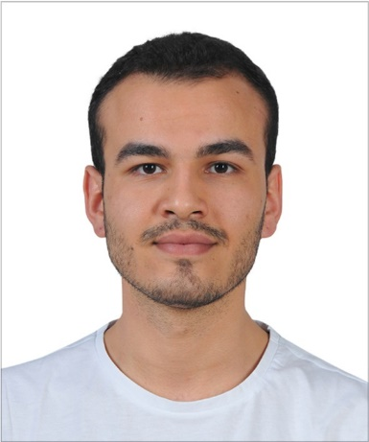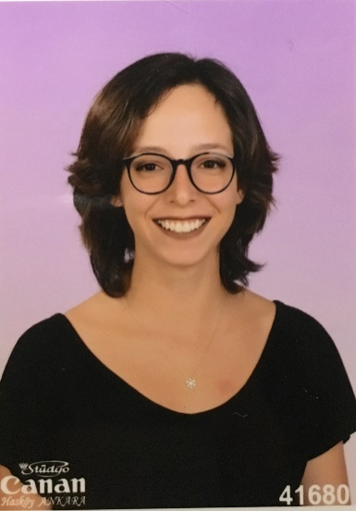

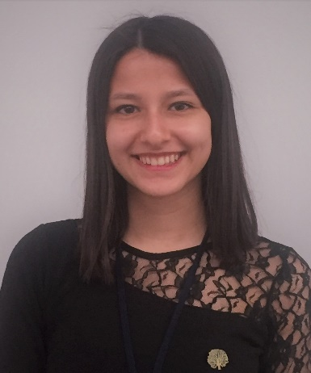

Elif Merve ÖZALP Emre Deniz ŞENEL Fahri TÜREDİ

2329746 2167237 2167435



Melike YILDIRIM Yunus YİLMAZ

2167591 2167658

Table of Contents

INTRODUCTION 3

VISION 3

MISSION 3

HUMAN RESOURCES 3

PROJECTS 3

CAT FEEDING 3

VALE PARKING 3

GIMME FAST 3

WHERE AM I? 3

CONCLUSION 3

APPENDICES 3

# INTRODUCTION

Introduction: IMPETUS Corporation was established in September 2019 by five electrical and electronics engineering students at Middle East Technical University. The very first meeting of the company members took place at Çatı Cafe. The goal which brings the company members together is to produce intelligent solutions to everyday problems.The company pays attention to collect people from different fields of electrical and electronics engineering. The main specializations of the members are electronics, power electronics, and control. This field division among the members helps the company to come up with distinguished approaches to various problems, as well as to create an opportunity for the members to work on their area of specialization.

# VISION

Following the guiding mind and science, our aim is to be an innovative and environmental-friendly technologycompany for a sustainable and livable world.

# MISSION

Primarily focusing on the needs of clients, to create innovative, reliable, time and energy efficientsolutions in the field of electrical and electronics engineering.

# HUMAN RESOURCES

Since the very first gathering of the IMPETUS Corporation, diversity is an essential element of the company. Different ideas and various point of views are the keys of developing a strong culture. For this purpose, IMPETUS Corporation aims to gather experts from divergent specialization areas.

Elif Merve ÖZALP –Electronics Specialist

Specialized in electronics field. Her interests in semiconductor devices and quantum physics lead her to be in electronics division in IMPETUS Corporation.

Emre Deniz ŞENEL – Power Electronics Specialist

Specialized in power electronics and electromechanical energy conversion field. He feels enthusiastic about autonomous electric vehicles and motor drivers.

Fahri TÜREDİ – Electromechanical Systems Specialist

Specialized in electromechanical systems and design. His passion for Formula1 and electric vehicles fosters him to be part of the IMPETUS Corporation.

Melike YILDIRIM – Control Systems Specialist

Specialized in control systems and bio robotics. Her interests mainly focus on bio-inspired intelligent machines and signal processing.

Yunus YİLMAZ – Computer and Communication Specialist

Specialized in computer systems and communication. His works on communication protocols and mobile applications lead him to be a computer specialist in IMPETUS Corporation.

# PROJECTS

## CAT FEEDING

## VALE PARKING

## GIMME FAST

The project requires a system which can transfer complementary data packets via visible light communication. At the beginning, camera module will take a picture. Then, the picture will be divided into data packets of less than 10 kB . The transmission of the packets will be provided by visible light; that is, light-emitting diodes and photodiodes. First transmission will be done from the camera side to the vehicle side. The vehicle physically carries the data to the receiver side. Second transmission will be done from the vehicle to the receiver side. On the receiver side, the data packets will be reconstruct the picture and the picture will be displayed on a screen. There are some restrictions about the project as following:

* Maximum 8 LEDs and 8 photodiodes can be used in the system.
* The vehicle cannot approach terminals less than 5 cm.
* The vehicle must complete at least 5 full rounds to carry the whole picture.
* The transfer should be completed in less than 2 minutes.

According to the restrictions, both transmitter ends may contain 4 LEDs and both receiver ends may contain 4 photodiodes. These 4 pair can transmit 4 packets at the same time at different frequencies. Each photodiode should contain a band pass filter to reduce noise and discard possible received undesired packets. In order to increase the transmission speed, high frequencies can be selected according to LED’s and photodiodes properties. The vehicle should be fast enough to transmit the picture in five full rounds in two minutes.

The project requires a lot of information about the communication theory. The system needs a lot of optimizations. The algorithm behind the dividing the picture into packets and reconstruction of the picture from the packets should be consistent in each other.

## WHERE AM I?

# CONCLUSION

# APPENDICES

--CV’leriburayaekleyiniz.